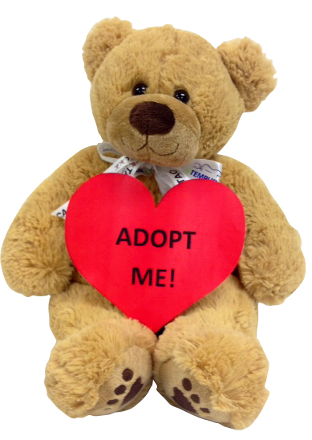
Stuffed Animal
Adoption Blitz Sale

2 for 1 sale: $5 for 2 animals or $5 for 4 beanie babies
ONE DAY ONLY!! ON 3/31/17 from 9:30 - 9:50a.m.

Last chance to adopt a stuffed animal to benefit our Campus Beautification Project.

